**Reflexes**

The spinal cord runs lengthways inside a vertebral column (spine) and conveys information to and from the brain. The spinal cord can also act independently of the brain as part of a simple nerve circuit that produced reflexes. A reflex is the body’s automatic response to certain stimuli.

A reflex protects the body by triggering a rapid, involuntary response to a particular stimulus. For example, if you put your hand on a hot stove, a reflex begins to pull your hand back well before the sensation of pain has been processed by your brain. Similarly, if your knees buckle when you pick up a heavy object, the tension across your knees triggers a reflex that contracts the thigh muscles, helping you stay upright and support the load. During a physical exam, your doctor might trigger this knee jerk reflex with a mallet to help assess nervous system function.

**Figure 1: The Knee-jerk Reflex.**

Note: Many neurons are involved in the reflex, but for simplicity only a few a shown.

1. Motor neurons convey signals to quadriceps, causing it to contract and jerking the lower leg forward.

[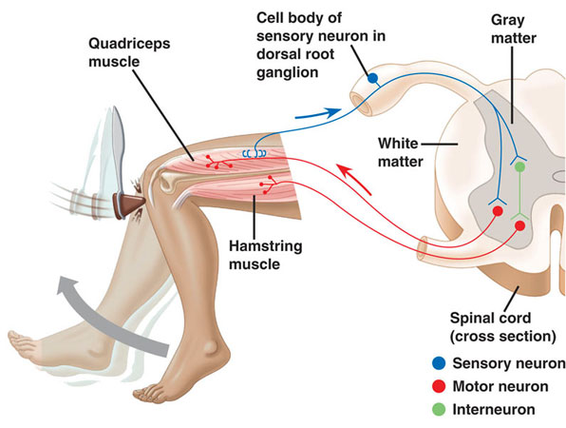](http://www.google.com.au/url?sa=i&rct=j&q=&esrc=s&source=images&cd=&cad=rja&uact=8&ved=0ahUKEwjg9Nn0jsTSAhUIrJQKHXD4Bv0QjRwIBw&url=http://www.edoctoronline.com/tag/knee-reflex-action&bvm=bv.148747831,d.dGc&psig=AFQjCNH5LOueL29tJh5H6uCJ8mskT8oKvg&ust=1488966582519951)

1. Interneurons inhibit motor neurons that lead to hamstring muscle. This inhibition prevents contraction of the hamstring, which would resist the action of the quadriceps.
2. Sensory neurons communicate with interneurons in the spinal cord.
3. Sensory neurons convey information to the spinal cord.
4. Sensors detect a sudden stretch in the quadriceps.
5. The reflex is initiated artificially by tapping the tendon connected to the quadriceps muscle.

**CHECK FOR UNDERSTANDING**

1. Define the term reflex.
2. Explain why reflexes are an important function of the nervous system.
3. Draw a diagram to explain the reflex involved in involuntarily removing your hand from a hot stove. Your diagram should include labelled sensory, inter and motor neurons.

**Reflexes**

The spinal cord runs lengthways inside a vertebral column (spine) and conveys information to and from the brain. The spinal cord can also act independently of the brain as part of a simple nerve circuit that produced reflexes. A reflex is the body’s automatic response to certain stimuli.

A reflex protects the body by triggering a rapid, involuntary response to a particular stimulus. For example, if you put your hand on a hot stove, a reflex begins to pull your hand back well before the sensation of pain has been processed by your brain. Similarly, if your knees buckle when you pick up a heavy object, the tension across your knees triggers a reflex that contracts the thigh muscles, helping you stay upright and support the load. During a physical exam, your doctor might trigger this knee jerk reflex with a mallet to help assess nervous system function.

**Figure 1: The Knee-jerk Reflex.**

Note: Many neurons are involved in the reflex, but for simplicity only a few a shown.

1. Motor neurons convey signals to quadriceps, causing it to contract and jerking the lower leg forward.

[](http://www.google.com.au/url?sa=i&rct=j&q=&esrc=s&source=images&cd=&cad=rja&uact=8&ved=0ahUKEwjg9Nn0jsTSAhUIrJQKHXD4Bv0QjRwIBw&url=http://www.edoctoronline.com/tag/knee-reflex-action&bvm=bv.148747831,d.dGc&psig=AFQjCNH5LOueL29tJh5H6uCJ8mskT8oKvg&ust=1488966582519951)

1. Interneurons inhibit motor neurons that lead to hamstring muscle. This inhibition prevents contraction of the hamstring, which would resist the action of the quadriceps.
2. Sensory neurons communicate with interneurons in the spinal cord.
3. Sensory neurons convey information to the spinal cord.
4. Sensors detect a sudden stretch in the quadriceps.
5. The reflex is initiated artificially by tapping the tendon connected to the quadriceps muscle.

**CHECK FOR UNDERSTANDING**

1. Define the term reflex.
2. Explain why reflexes are an important function of the nervous system.
3. Draw a diagram to explain the reflex involved in involuntarily removing your hand from a hot stove. Your diagram should include labelled sensory, inter and motor neurons.